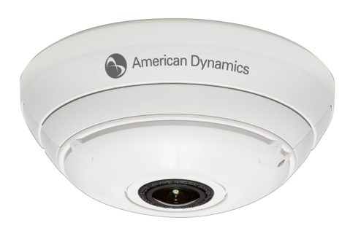
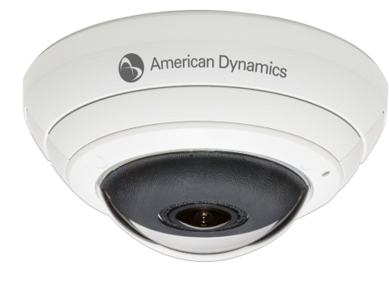

Vandal-Resistant
Non Vandal-Resistant

Description

The Illustra 825 Fish Eye 5MP Camera (hereafter referred to as i825FE) operates across an IP network, e.g. the Internet, a LAN or WAN. The video output from the camera is compressed and sent across the network using IP transport mechanisms allows complete functionality at a remote location connected by any kind of IP network. A built-in web server provides web pages to configure the dome and streams the video using a customer-selected set of protocols with a standardized transport stream. This will also support other metadata as required. Emails and movie clips (AVI) may be sent across the network in response to alarms. The i825FE can operate as a standalone camera on a network however it is intended to be integrated into sophisticated security solutions.

The i825FE can network with network video recording systems using Illustra API v3.0. These systems include American Dynamics victor Unified Client, American Dynamics VideoEdge NVR, VideoEdge Hybrid, ExacqVision NVR systems v5.10, American Dynamics HDVR v2.4 and Kantech Intevo v2.4.

The i825FE is a Network Video Transmitter, NVT, compliant with ONVIF 2.4 profile S standards, and can interface with network video clients supporting ONVIF.

The i825FE is compatible with the American Dynamics Illustra Connect tool which provides discovery, configuration, firmware upgrade and diagnostics using ONVIF and WS Discovery protocols.

Sleek, discreet design allows it to blend into any environment for inconspicuous surveillance.

The vandal-resistant model protects the camera against external impacts.

The i825 Fisheye cameras include a mounting adaptor for installations using standard single-gang and double-gang electrical boxes.

For pendent installation, the i825 Fisheye cameras can be used with the Illustra 600 Series White Outdoor Pendent Cap (ADCI6DPCAPOW).

It is extremely easy to install and simple to set up.

A built-in web server provides easy configuration.

Key differentiators are:
- 5MP imager for super high quality images with fisheye resolution up to 1936x1936 or 3.7MP
- 360°/180° dewarped panoramic views of wide areas
- Single or multiple active views for forensic investigations
- Onboard dewarping for distortion-free images
- ePTZ capabilities for ultra smooth transition between pan, tilt and zoom
- Efficient bandwidth and video storage to reduce costs
- Onboard SD card recording and storage
- Sleek, discreet design
- Quick and easy installation
- Vandal-resistant model available
- ONVIF 2.4 profile S compliant
- Low Latency
- Progressive scan imager with full digital path to output

- Performance Specifications

The i825FE supports Ethernet 100/100 Base-T via a RJ45 connection with support for HTTP, TCP/IP, RTP, RTSP, DHCP, multicast, and DDNS client protocols.

The i825 FE supports live video via the web pages using Internet Explorer 8 or higher or proprietary client software.

The i825 FE has a 1.27mm, IR Corrected lens delivering a 183° Field of View (FOV)
The i825FE uses DNS protocol to resolve network names and also DDNS Dynamic Domain Name System for updating, in real time, a changing IP address on the Internet to provide a persistent domain name for a resource that may change location on the network per RFC 2136 Dynamic Updates in the Domain Name System.

The i825FE supports NTP for time synchronization.

The i825FE supports sending IP multicast streams of audio, video and metadata

The i825FE is able to send email alerts via SMTP to one specified mailbox using a specified SMTP server. The product supports basic authenticated SMTP using username and password for login on the SMTP server.

The product supports WS-Discovery for discovery purpose.

The i825FE is supplied with a copy of Illustra Connect; an MS-Windows based discovery application, which will allow any Illustra camera and other ONVIF cameras (some cameras might be incompatible) on a network to be discovered. For each camera found on the network, the discovery tool will list and allow display filtering by the following:
- Device Name
- Hostname
- IP Address
- Model Name
- Product Code
- Manufacturer
- Firmware Version
- Status
- MAC Address

The i825FE interfaces with the Illustra Connect application to provide a robust tool for discovery, snapshot, configuration, diagnostics, and firmware upgrade; the following is provided:
- As an alternate to the list display a snapshot view of all cameras can be displayed.
- Device properties windows can be opened to show a snapshot of the camera view, network settings, UUID (ONVID identification code), serial number, and many other device properties.
- Support of IPv4 and IPv6 together or separately with user choice preference for dual stack devices.
- Resolve IP address conflicts and configure devices with static IP addressed or DHCP
- Configure individual device network setting.
- Provides a device list in exportable CVS format
- User account control to secure full administrator access
- Device maintenance allows individual device configuration
- Device maintenance allows three types of reset/reboot:
  - Reset to factory defaults and change IP settings
  - Reset to factory defaults and preserve IP settings
  - Reboot maintaining current settings
- Multiple devices can be updated with one operation for the following:
  - Time
  - Date
  - NTP server
  - Upgrade firmware
  - User accounts
  - Network settings
- Provided as a virtualized standalone .exe file that does not require PC installation. This self contained version of Illustra Connect can run with no prerequisites, and can also be used from a USB flash drive.
- The Illustra Connect tool is also available as an installation setup file which will be able to store any user specified detail such as security settings and network preferences for future use.
- Both the virtualized and installation files of Illustra Connect are available for download from the American Dynamics website.
- Supports all the language options of the i825FE camera

The following information is available for display in the i825FE GUI:
- Camera Name
- Model
- Product Code
- Manufacturing Date
- Serial Number
- MAC Address
- Firmware Version
- Hardware Version

The System Log is available for display in the GUI, this provides the most recent messages from the Unix /var/log/messages file, and the information will include the following:
- Messages about system behavior such as process startup/shutdown.
- Warnings about recoverable problems that processes encounter.
- Error messages where processes encounter problems they cannot fix, even if it can continue to work.

The i825FE provides a Boot log, which is a log of the Linux operating system boot processes and is useful to
American Dynamics support engineers who require additional information on the device.

- Minimum Performance Specifications

Camera
Video Compression | H.264/MJPEG
Max Frame Rate | 14ips
ONVIF Compliant | Yes
Imager | Type 1/2.5” 5MP CMOS Sensor
Minimum Illumination | 1.2 lux
Shutter | AES (Automatic Electronic Shutter)
Lens Focal Length | 1.37mm
Aperture | 2.0
Field of View | 183°
PTZ | Digital pan/tilt/zoom, presets, sequences, patterns, scans
White Balance | Auto Normal, Auto Wide and Manual
Alarms | Motion detection
Wide Dynamic Range | 82dB
Privacy Zones | Yes, 4
Menu Languages | English (default), Arabic, Czech, Danish, German, Spanish, French, Hungarian, Italian, Korean, Japanese, Netherlands, Polish, Portuguese, Swedish, Turkish, Chinese Traditional, Chinese Simplified
Resolutions
Fisheye | 1936x1936
Active image 1-4 | 960x540
 | 800x450
 | 640x360
 | 480x270
 | 320x180
Wall/Ceiling Panorama | 1920x1080
 | 1600x900
 | 1280x720
 | 1024x576
 | 960x540
 | 800x450
 | 640x360
 | 480x270
 | 320x180
Network
Ethernet | 10/100Base-T
Supported Protocols | TCP/IP, IPv4, IPv6, TCP, UDP, HTTP, FTP, DHCP, WS-Discovery, DNS, DDNS, RTP, TLS, Unicast, Multicast, NTP, SMTP, WS-Security
Base Protocol | TCP/IP - RFC4614
Internet Layer Addressing | IPv4 - RFC791
 | IPv6 - RFC2460
Transport Layer | TCP - RFC973
 | UDP - RFC768
Data Transmission | HTTP - RFC2616
 | FTP - RFC959
Network Address Configuration | DHCP - RFC2131
 | Zeroconf - RFC3927
 | Static IP address
Network Name Resolution | DNS - RFC5395
 | DDNS - RFC 2136
Time Synchronization | NTP - RFC1305
 | IETF NTP Working Group
 | 1 minute poll rate
Email | SMTP - RFC5321
 | Authenticated SMTP - RFC4954
Authentication and Security | TLS - RFC5346
 | HTTPS (HTTP over TLS) - RFC2818
 | WS-Security
Discovery | WS-discovery - ws-discovery.pdf
Streaming | RTP - RFC3550
 | RTSP - RFC2326
 | Unicast Streaming
 | Multicast Streaming - RFC1112 level 1
External Interface Protocol | AD Illustra API 3.0
 | SOAP - SOAP 1.2
 | ONVIF
 | WS-Addressing
 | WS-Eventing
Onboard Storage
Card Type | 32 GB Micro SDHC
Electrical
Power | PoE 802.3af Class 3
Power Consumption | <12.95W
Surge Protection | Data lines isolation transformer coupled
Connectors | RJ-45 for 10 BaseT/100BaseTX
Physical
Body Diameter | 149mm (5.85in)
Height Above Ceiling | 25.4mm (1.0in required for cable clearance)
Height Below Ceiling | Vandal-Resistant | 60mm (2.36in)
 | Non Vandal-Resistant | 74mm (2.91in)
Weight | Vandal-Resistant | 0.750 kg
 | Non Vandal-Resistant | 0.730 kg
Environmental
Operating Temperature | -10°C to 45°C (14°F to 113°F)
Humidity | 95% non-condensing
Storage Temperature | -20°C to 65°C (-4°F to 149°F)
Regulatory
Emissions | FCC CFR 47 Part 15 Class A
 | AS/NZS CISPR22 Class A
 | ICES-003/NMB-003 Class A
 | EN 55022
Immunity | EN50130-4
 | EN 61000-6-1
 | IEC 62599-2
 | EN 55024
Safety | UL 60950-1
 | CSA 22.2 No. 60950
 | EN 60950-1
 | IEC 60950-1
Environmental | RoHS, EU Directive 2002/95/EC
 | WEEE, EU Directive 2002/96/EC
Physical Protection | IK10

