illustra 610LT
Indoor Fixed Dome HD (High Definition) Cameras

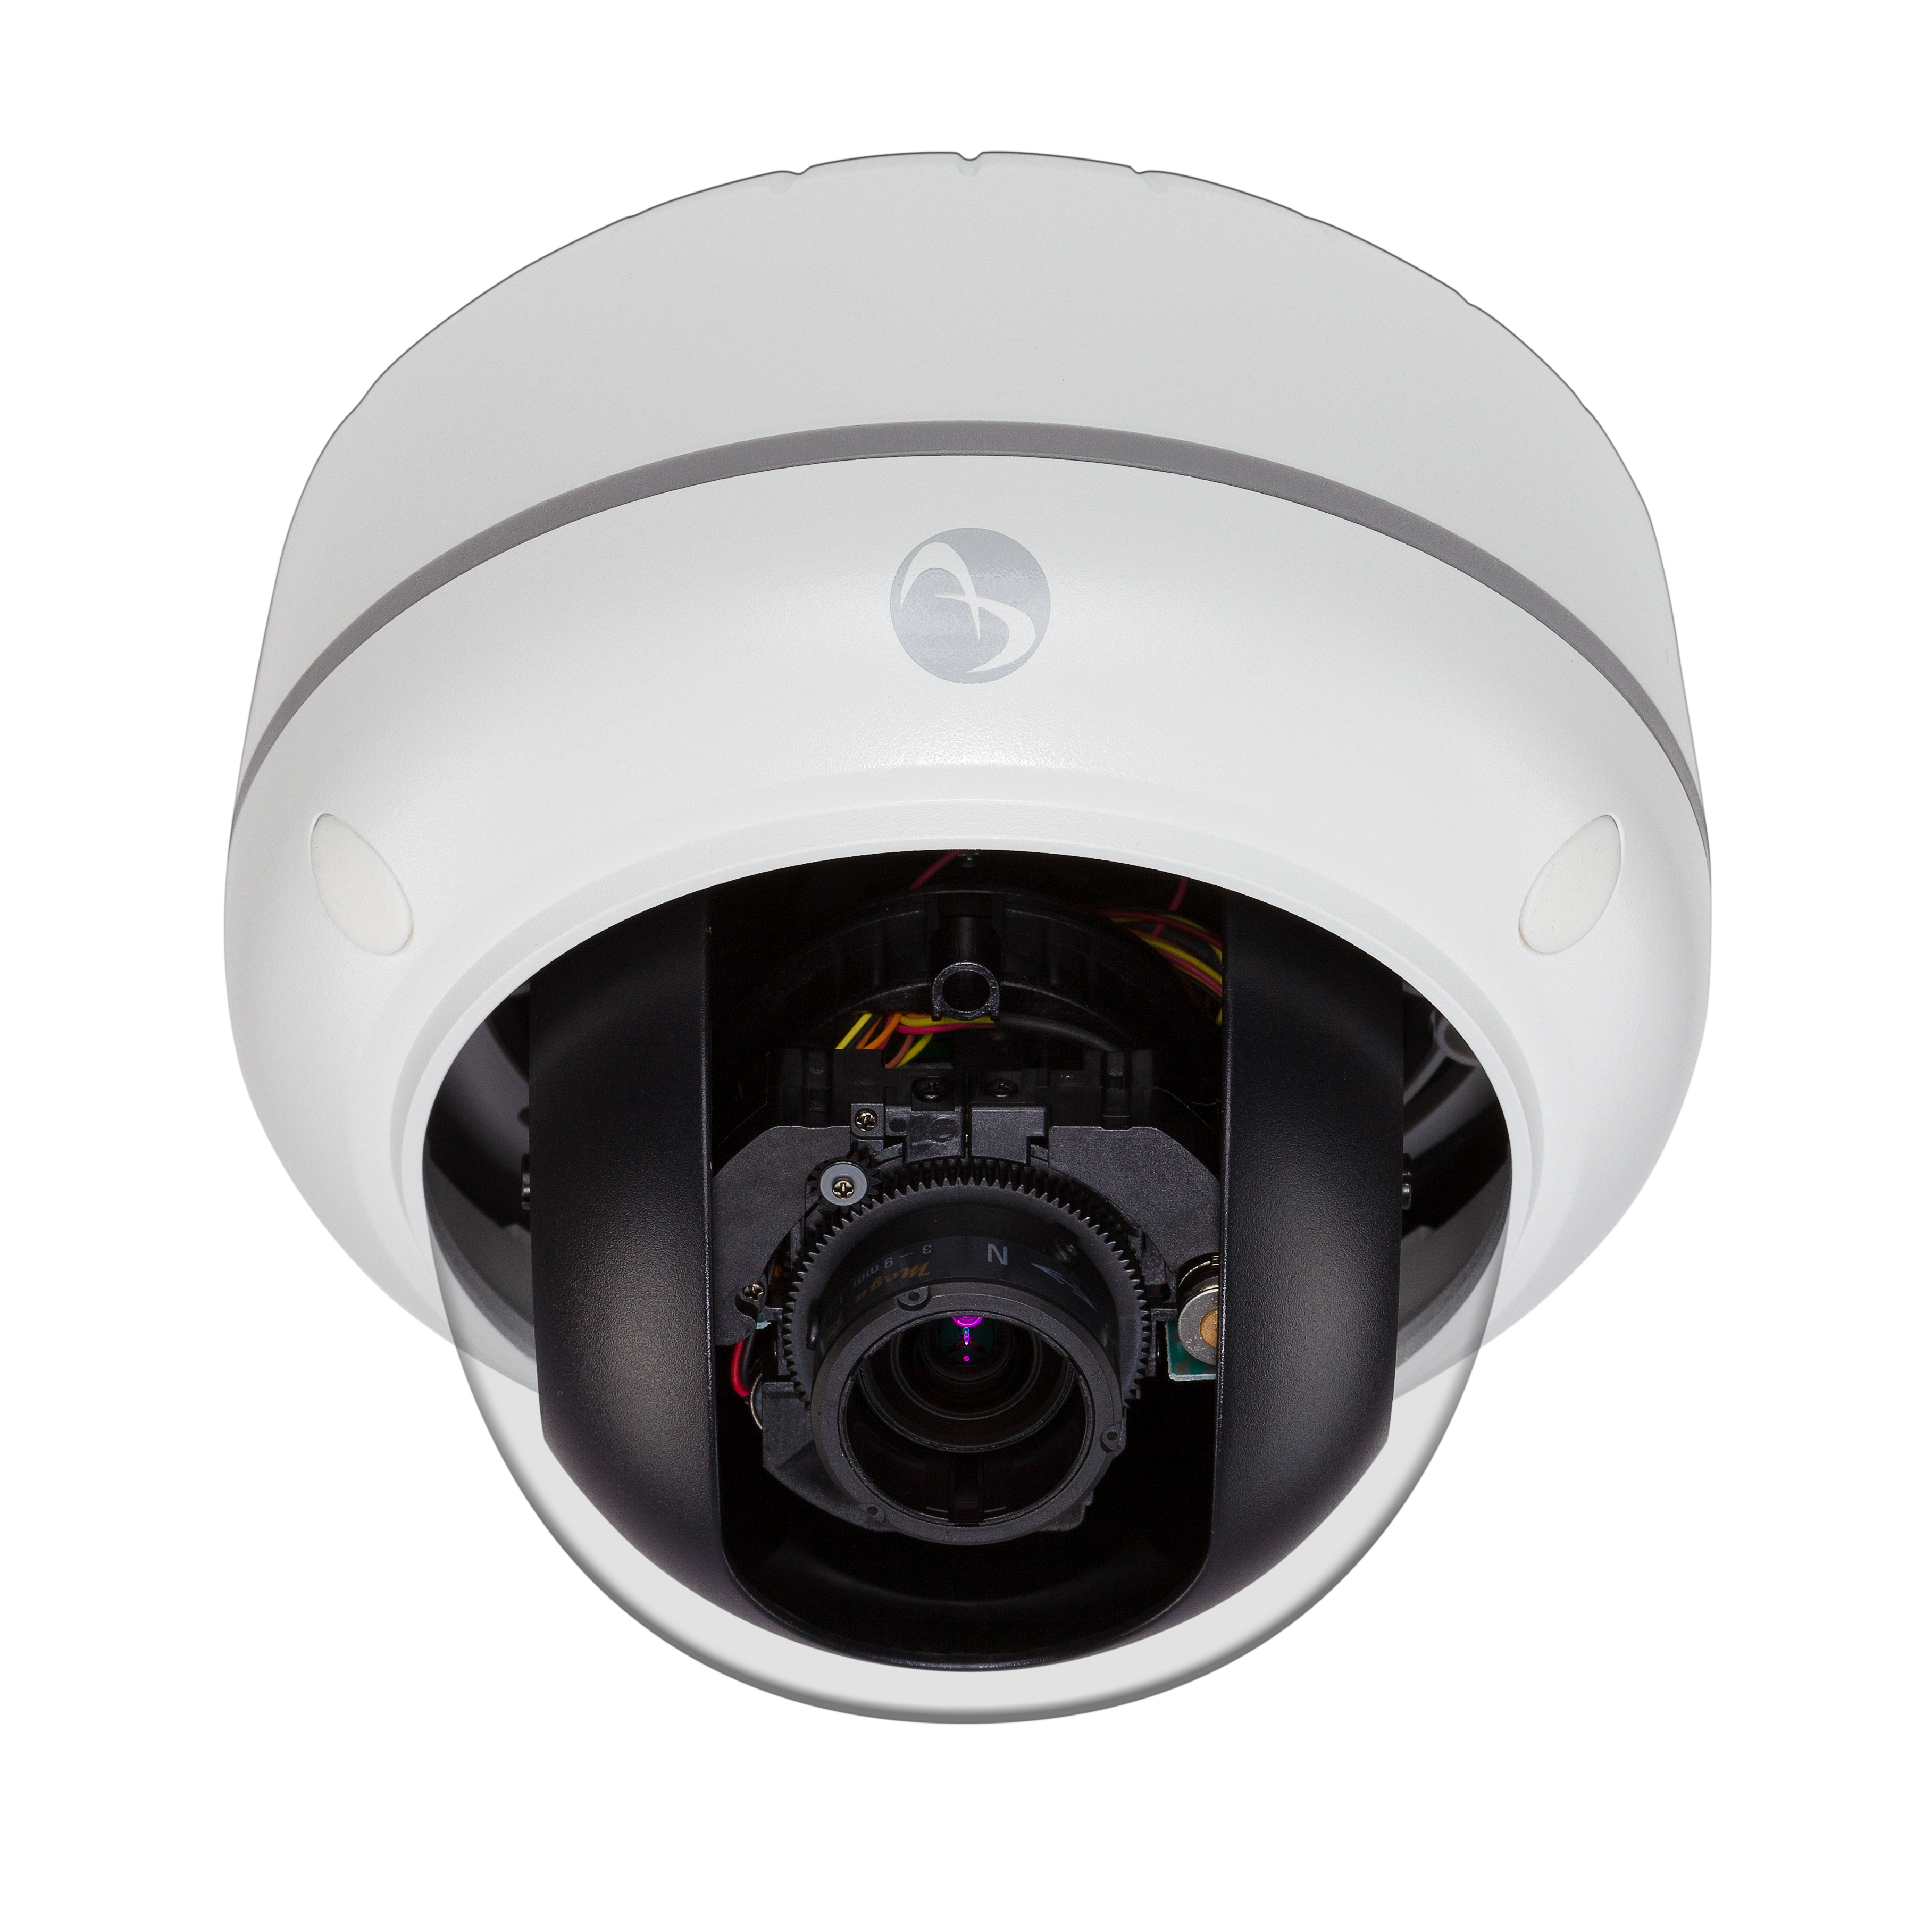

American Dynamics makes no representations or warranties with respect to the contents hereof and specifically disclaims any implied warranties of merchantability or fitness for any particular purpose. Furthermore, American Dynamics reserves the right to revise this publication from time to time in the content hereof without the obligation to notify any person of any such revision or changes.

NOTE:
The specifier should carefully select the portions of this document that fit the intended application. Feel free to consult with American Dynamics regarding your particular application.

8200-2755-23 A0

Contents

1 Bid-Spec 3
2 Product Description 4
3 Product Quick Specification 6
3.1 Quick Spec for the 600/610 Dome Models 6
4 Model Numbers and Descriptions 8

Bid-Spec

The illustra 610LT HD IP cameras are a lower cost option in the illustra line of cameras that offer high definition 1080P resolution without some camera features that are included in the rest of the illustra 610 product line. They operate across an IP network such as the internet, a LAN or a WAN. Low light performance at 0.3 color, and .04 lux in black and white, leads the industry in clarity at all light levels. These cameras can power themselves via PoE (802.3af).

The mini-domes are vandal resistant, and have integrated surface, electrical box and recessed mounting, eliminating the need for additional hardware and cost. In addition, the cameras are also plenum-rated. These ONVIF-compliant cameras provide a range of options including on-board motion detection, wide dynamic range and exposure control. These features make them the premier choice in high definition cameras on the market today.

Key differentiators are:
- Digital wide dynamic range for clarity in backlit environments
- Hard and recessed mounts for easier and faster installation
- Leading low light CMOS clarity
- H.264 compression with 30 ips
- Resolution up to up to 1920x1080p
- Dome models use motorized zoom and one-touch auto focus for 3-9mm lens

Product Description

- The mini-dome cameras have an integrated 3-9mm IR corrected varifocal lens.

- The 3-9mm lens has a motorized zoom function with remote operation via the camera’s web interface.

- The 3-9mm lens has a one-touch auto focus feature with remote operation via the camera’s web interface.
- The camera dome chassis is vandal resistant, constructed of aluminum with a polycarbonate dome bubble.
- The dome camera has a 3-axis gimbal with 360° pan, 70° tilt, and 180° Z-rotation for easy and accurate positioning.
- The camera is surface mountable with no additional hardware needed.

- The camera has threaded conduit access in the rear and side of the body.

- The camera has an optional pendant mount or wall mount.

- The optional wall mount has conduit access via the rear, right and left sides of the mount.

- The indoor camera has a recess or flush mount without additional hardware.

- The camera attaches to single or double gang electrical boxes without an adapter.

- The camera supports both H.264 and MJPEG compression.
- The camera has dual standard compression support with simultaneous streaming of both H.264 and MJPEG formats.
- The camera has dual non-identical concurrent streams (different frame rate, bit rate, resolution, quality and compression format).
- The camera has Real Time Streaming Protocol (RTSP) support allowing for compatibility with media players such as Windows Media Player, Apple QuickTime, VLC Player and others.
- The camera’s output at its maximum resolution 1910(H) x1080(V) pixels at a maximum frame rate of 30 frames per second (FPS).
- It is possible to program the camera to output a variety of lower resolution images, i.e., CIF and 4 CIF 30 FPS.
- The camera provides 5 level settings for quality of H.264 compression.

- The camera has the options to operate with the H.264 codec in constant bit rate, variable bit rate, and constrained variable bit rate modes
- The camera supports HTTP and RTSP/RTP network protocols.
- The cameras feature motion detection with a minimum of 25 independent detection zones.
- The cameras feature automatic exposure, automatic white balance, shutter speed control, 50/60Hz selectable flicker control, programmable brightness, saturation, gamma, sharpness, windowing and decimation, simultaneous delivery of full-field view.
- The camera incorporates necessary algorithms and circuits to detect motion in low light with clarity.
- The camera supports a minimum illumination of 0.1 Lux @ F1.2 in color mode.
- The camera’s primary power source is Power over Ethernet (PoE) complying with the IEEE 802.3af standard.
- The indoor camera has the alternative option to be powered from between a 12V DC or 24V AC power source providing at least 5W of power.
- The camera is FCC Part 15, Class A and CE compliant.

- The camera is UL listed.

- The recessed indoor camera models are UL rated as suitable for use in environmental air handling spaces, other than inside air ducts or furnace plenums, and so stated in the installation manual.

- The camera is able to detect up to 5 faces in a scene
- Τηε χαμερα χαν στορε ανδ υτιλιζε τηε υσερ ναμε ανδ πασσωορδ οφ τηε ΣΜΤΠ σερϖερ το εναβλε προτεχτεδ εμαιλ εξπορτ.
- Τηε χαμερα ηασ τηε χαπαβιλιτψ το προϖιδε ατ λεαστ 3 ινδεπενδεντ πριϖαχψ ζονεσ.
- Τηε χαμερα ηασ α Λινυξ βασεδ οπερατινγ σψστεμ.
- Τηε χαμερα χαν σενδ αν αλαρμ βασεδ ον ον−βοαρδ μοτιον δετεχτιον.

- Τηε χαμερα χαν σενδ αν αλαρμ βασεδ ον τηε δετεχτιον οφ α φαχε.

- Τηε χαμερα χαν σενδ αν αλαρμ ωηεν τηε ιμαγε βεινγ βλυρρεδ ορ ουτ οφ φοχυσ.
- Τηε χαμερα συππορτσ ωιδε δψναμιχ ρανγε υπ το 70δΒ ωιτη 5 θυαλιτψ σεττινγσ.

- Τηε χαμερα ισ οφφερεδ ιν ωηιτε ονλψ

- Τηε χαμερα ηασ χοϖερσ φορ τριμ ρινγ σχρεωσ τηατ ματχη τηε χολορ οφ τηε τριμ ρινγ.

Product Quick Specification

Quick Spec for the 600/610 Dome Models

Video
Compression. . . . . . . . . . . . . H.264, MJPEG
Max Frame Rate. . . . . . . . . . . H.264 30 ips 1920x1080
MJPEG: 30 ips 1920x1080
ONVIF-Compliant. . . . . . . . . . Yes

Camera
Video Output . . . . . . . . . . . . . 1.0 Vp-p, 75 ohm, composite, RCA
Resolution . . . . . . . . . . . . . . . CIF, 4 CIF, 720p
Imager. . . . . . . . . . . . . . . . . . 1/2.7” inch CMOS progressive scan
Day/Night. . . . . . . . . . . . . . . . Auto (true day/night)
Motion Detection . . . . . . . . . . Yes
Alarms. . . . . . . . . . . . . . . . . . .Motion, schedule, Ethernet loss, blur detection, face
detection
Audio. . . . . . . . . . . . . . . . . . . Not supported
Video Streams. . . . . . . . . . . . 3 simultaneous streams

Minimum Illumination . . . . . . . 0.1 lux at F1.2 color

Wide Dynamic Range. . . . . . . 70dB, 5 level settings
Lens Type. . . . . . . . . . . . . . . . 3-9mm varifocal, IR corrected
Auto-Iris Support . . . . . . . . . . No
Plenum-Rated . . . . . . . . . . . .Yes

Network
Interface. . . . . . . . . . . . . . . . . Ethernet 10/100Base-TX
Ethernet Port. . . . . . . . . . . . . .RJ-45
Supported Protocols . . . . . . . TCP/IP, DHCP, HTTP, ICMP, UPnP, ARP, DNS,
DDNS, PPPoE, SMTP, FTP, RTSP
Configuration Management
Web Browser. . . . . . . . . . . . . MS IE 6.x or greater, Mozilla Firefox, Chrome
Security . . . . . . . . . . . . . . . . . Multi-level; multi-users; IP address filtering, user access log, HTTPS

Simultaneous Users. . . . . . . .Eight

Electrical
Power Input. . . . . . . . . . . . 12VDC -10% ~ +10%
24VAC -20%~ + 30% 47 to 63 Hz
PoE IEEE 802.3af

Power Draw. . . . . . . . . . . . . …….
Illustra 600LT | 24 VAC | 12VDC | PoE+  IEEE 802.3at™
Indoor | 6.5W | 6.5W | 6.5W

Physical
Dimensions (W x H). . . . . . …….130mm x 120 mm (5.11 in. x 4.72 in.)
Weight. . . . . . . . . . . . . . . . . . …..907 kg (2 lbs)
Housing Color . . . . . . . . . . . . …..White or black
Operating Temperature. . . . . . ….-10° to 50°C (-22° to 122°F)

Regulatory
Emissions. . . . . . . . . . . . . . . . ….FCC 47 CFR, Part 15, Class A
EN55022, Class A
ICES-003, Class A
AS/NZS CISPR22, Class A
Immunity . . . . . . . . . . . . . . . . …. EN50130-4
Safety. . . . . . . . . . . . . . . . . . . …. UL 60950-1, 2nd Ed
EN 60950-1, 2nd Ed
CSA C22.2 No.60950-1-07, 2nd Ed

Model Numbers and Descriptions

Model | Description
ADCi610LT | D111 Indoor HD LT 1080p minidome, auto focus, 3-9mm auto focus, PoE only, white, clear bubble
ADCi610LT | D113 Indoor HD LT 1080p minidome, auto focus, 3-9mm auto focus, PoE only, white, smoked bubble

