illustra 600/610 Series
Indoor/Outdoor Fixed Dome HD (High Definition) Cameras – Wide Angle and Telephoto Models

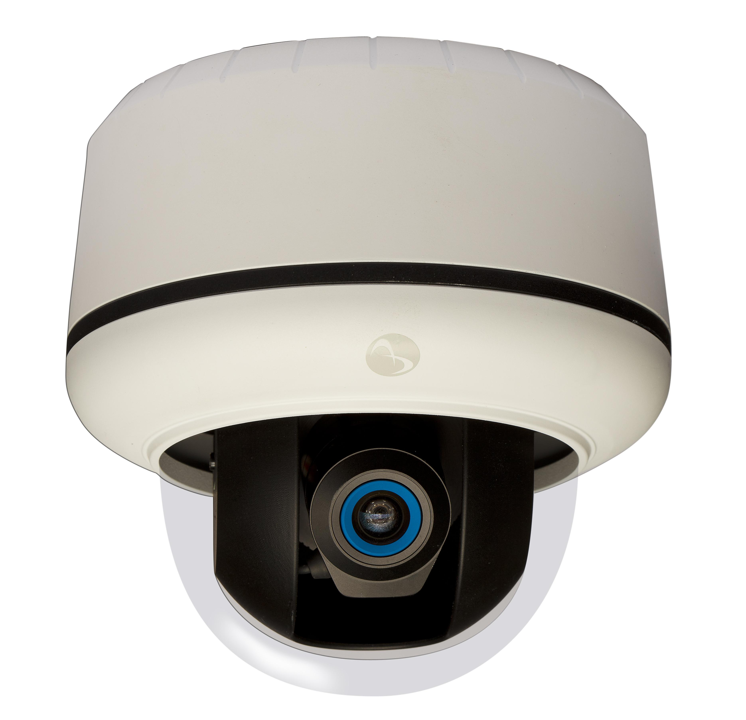

American Dynamics makes no representations or warranties with respect to the contents hereof and specifically disclaims any implied warranties of merchantability or fitness for any particular purpose. Furthermore, American Dynamics reserves the right to revise this publication from time to time in the content hereof without the obligation to notify any person of any such revision or changes.

NOTE:
The specifier should carefully select the portions of this document that fit the intended application. Feel free to consult with American Dynamics regarding your particular application.

8200-2755-24 A0

Contents

1 Bid-Spec 3
2 Product Description 4
3 Product Quick Specification 7
3.1 Quick Spec for the 600/610 Dome Models 7
4 Model Numbers and Description 9

Bid-Spec

The illustra 600 Series Wide Angle and Telephoto Models are designed for use in installations where a wider field of view or bringing distant objects closer are required. Installation of the Telephoto camera can help to avoid wire trenching costs for situations where use of the 9mm-40mm lens allows the camera to be installed on a building with existing IP network and power access rather than bringing the network and power to a remote camera location. The HD IP cameras are the next in the illustra line of cameras that offer high definition resolution and dynamic bandwidth management. They operate across an IP network such as the internet, a LAN or a WAN. Low light performance at 0.3 color, and .04 lux in black and white, leads the industry in clarity at all light levels. These cameras can power themselves via PoE (802.3af). The illustra 600 line offers versatility in both form factor and color options.

These intelligent cameras can detect faces in a region of interest and dynamically increase image quality. The mini-domes are vandal resistant, and have integrated surface and electrical box mounting options. These ONVIF-compliant cameras provide a range of options including on-board motion detection, wide dynamic range and exposure control. These features make them the premier choice in high definition cameras on the market today.

Key differentiators are:
- Digital wide dynamic range for clarity in backlit environments
- Hard and recessed mounts for easier and faster installation
- Face-detected regions of interest
- Leading low light CMOS clarity in color and black & white
- H.264 compression with 30 ips
- Resolution up to 1280x720p (Illustra 600) and up to 1920x1080p (Illustra 610)
- Wide angle model with Theia 1.8mm-3mm lens and Field of View of 77° - 106°
- Telephoto Model with Theia 9mm-4mm lens and Field of View of 6.9° - 30°

Product Description

- The mini-dome cameras have an integrated lens; Wide Angle Model includes Theia 1.8mm-3mm IR corrected varifocal megapixel lens (FOV 77° - 106°), Telephoto Model includes Theia 9mm-4mm lens 3mm IR corrected varifocal megapixel lens (FOV 6.9° - 30°).
- The camera dome chassis is vandal resistant, constructed of aluminum with a polycarbonate dome bubble.
- The dome camera has a 3-axis gimbal with 360° pan, 70° tilt, and 180° Z-rotation for easy and accurate positioning.
- The camera is surface mountable with no additional hardware needed.

- The camera has threaded conduit access in the rear and side of the body.

- The camera has an optional pendant mount or wall mount.

- The optional wall mount has conduit access via the rear, right and left sides of the mount.

- The indoor camera has a recess or flush mount without additional hardware.

- The camera attaches to single or double gang electrical boxes without an adapter.

- The outdoor dome cameras have an enclosure complying with IP66 and IP67 weatherproofing standards.

- The outdoor camera has an optional recess or flush mount kit that maintains the IP66 and IP67 weatherproof rating.

- The outdoor camera is operational to -40c

- The outdoor camera reduces or eliminates condensation from the field of view without the use of desiccant.

- The outdoor camera reduces or eliminates condensation from the field of view without the use of a fan.
- The camera supports both H.264 and MJPEG compression.
- The camera has dual standard compression support with simultaneous streaming of both H.264 and MJPEG formats.
- The camera has dual non-identical concurrent streams (different frame rate, bit rate, resolution, quality and compression format).
- The camera is compatible with both PAL or NTSC video formats
- The camera has Real Time Streaming Protocol (RTSP) support allowing for compatibility with media players such as Windows Media Player, Apple QuickTime, VLC Player and others.
- The camera’s output at its maximum resolution of 1280(H) x 720(V) or 1910(H) x1080(V) pixels at a maximum frame rate of 30 frames per second (FPS).
- It is possible to program the camera to output a variety of lower resolution images, i.e., CIF and 4 CIF 30 FPS.
- The camera provides 5 level settings for quality of H.264 compression.

- The camera has the options to operate with the H.264 codec in constant bit rate, variable bit rate, and constrained variable bit rate modes
- The camera supports HTTP and RTSP/RTP network protocols.
- The cameras feature motion detection with a minimum of 25 independent detection zones.
- The cameras feature automatic exposure, automatic white balance, shutter speed control, 50/60Hz selectable flicker control, programmable brightness, saturation, gamma, sharpness, windowing and decimation, simultaneous delivery of full-field view.
- The camera incorporates necessary algorithms and circuits to detect motion in low light with clarity.
- The camera supports a minimum illumination of 0.3 Lux @ F1.2 in color mode.
- The camera supports an IR sensitive minimum illumination of 0.04 Lux in B/W mode.
- The camera’s primary power source is Power over Ethernet (PoE) complying with the IEEE 802.3af standard.
- The camera has IR illuminators capable of illumination up to 60 feet powered by PoE (802.3af).
- The indoor camera has the alternative option to be powered from between a 12V DC or 24V AC power source providing at least 5W of power.
- The camera’s operating ambient temperature is -40°C (-40°F) to 50ºC (122ºF) for warm start conditions (for outdoor fixed dome models).
- The camera is FCC Part 15, Class A and CE compliant.

- The camera is UL listed.

- The recessed indoor camera models are UL rated as suitable for use in environmental air handling spaces, other than inside air ducts or furnace plenums, and so stated in the installation manual.

- The camera is capable of increasing the bit rate within up to 5 independent regions of interest.

- The camera is able to detect up to 5 faces in a scene and increase the bit rate in the area of those faces.
- The camera has the ability to directly export snapshot images in JPEG form and video clips via email, FTP, Network storage and on board SDHC card.
- Τηε χαμερα χαν στορε ανδ υτιλιζε τηε υσερ ναμε ανδ πασσωορδ οφ τηε ΣΜΤΠ σερϖερ το εναβλε προτεχτεδ εμαιλ εξπορτ.
- Τηε χαμερα χαν ρεχορδ το αν ΣΔΗΧ χαρδ βασεδ ον μοτιον δετεχτιον, φαχε δετεχτιον, αλαρμ ινπυτ, ορ ον σχηεδυλε μαναγεδ ϖια τηε χαμερα’σ ωεβ−βασεδ ΓΥΙ.
- Τηε χαμερα χαν ρεχορδ το α ΣΔΗΧ χαρδ ιν α χιρχυλαρ φασηιον.
- Ρεχορδεδ ϖιδεο ον τηε χαμερα’σ ΣΔΗΧ χαρδ ισ αχχεσσιβλε ϖια τηε χαμερασ ωεβ βροωσερ ΓΥΙ.
- Τηε χαμερα ηασ τηε χαπαβιλιτψ το προϖιδε ατ λεαστ 3 ινδεπενδεντ πριϖαχψ ζονεσ.
- Τηε χαμερα ηασ ατ λεαστ 1 αλαρμ ουτπυτ ανδ 2 αλαρμ ινπυτσ.
- Τηε χαμερα ηασ α Λινυξ βασεδ οπερατινγ σψστεμ.
- Τηε χαμερα συππορτσ βι−διρεχτιοναλ αυδιο ιν ηαλφ ανδ φυλλ δυπλεξ.

- Τηε χαμερα χαν σενδ αν αλαρμ βασεδ ον ον−βοαρδ μοτιον δετεχτιον.

- Τηε χαμερα χαν σενδ αν αλαρμ βασεδ ον αυδιο δετεχτιον.

- Τηε χαμερα χαν σενδ αν αλαρμ βασεδ ον τηε δετεχτιον οφ α φαχε.

- Τηε χαμερα χαν σενδ αν αλαρμ ωηεν τηε ιμαγε βεινγ βλυρρεδ ορ ουτ οφ φοχυσ.
- Τηε χαμερα συππορτσ ωιδε δψναμιχ ρανγε υπ το 70δΒ ωιτη 5 θυαλιτψ σεττινγσ.

- Τηε χαμερα ισ οφφερεδ ιν ωηιτε ανδ βλαχκ χολορσ.

- Τηε χαμερα ηασ χοϖερσ φορ τριμ ρινγ σχρεωσ τηατ ματχη τηε χολορ οφ τηε τριμ ρινγ.

Product Quick Specification

Quick Spec for the 600/610 Dome Models
Video
Compression. . . . . . . . . . . . . H.264, MJPEG
Max Frame Rate. . . . . . . . . . . Illustra 600
H.264 30 ips 1280x720
MJPEG: 30 ips 1280x720
Illustra 610
H.264 30 ips 1920x1080
MJPEG: 30 ips 1920x1080
ONVIF-Compliant. . . . . . . . . . Yes

Camera
Video Output . . . . . . . . . . . . . 1.0 Vp-p, 75 ohm, composite, RCA
Resolution . . . . . . . . . . . . . . . CIF, 4 CIF, 720p
Imager. . . . . . . . . . . . . . . . . . 1/2.7” inch CMOS progressive scan
Day/Night. . . . . . . . . . . . . . . . Auto (true day/night)
Motion Detection . . . . . . . . . . Yes
Alarms. . . . . . . . . . . . . . . . . . .Motion, schedule, dry contact, Ethernet loss, blur detection, face
detection
Audio. . . . . . . . . . . . . . . . . . . Bi-directional duplex, half-duplex
Alarm input/output. . . . . . . . . ..2/1
Video Streams. . . . . . . . . . . . 3 simultaneous streams

Minimum Illumination . . . . . . . Illustra 600
0.3 lux at F1.2 color; 0.04lux at F1.2 b/w

Illustra 610
0.3 lux at F1.2 color; 0.04 lux at F1.2 b/w

Wide Dynamic Range. . . . . . . 70dB, 5 level settings
Lens Type. . . . . . . . . . . . . . . . 1.8-3mm varifocal (wide angle model) or
9-40mm varifocal (telephoto model)
Auto-Iris Support . . . . . . . . . . No
Plenum-Rated . . . . . . . . . . . .Yes

Network
Interface. . . . . . . . . . . . . . . . . Ethernet 10/100Base-TX
Ethernet Port. . . . . . . . . . . . . .RJ-45
Supported Protocols . . . . . . . TCP/IP, DHCP, HTTP, ICMP, UPnP, ARP, DNS,
DDNS, PPPoE, SMTP, FTP, RTSP

Configuration Management
Web Browser. . . . . . . . . . . . . MS IE 6.x or greater, Mozilla Firefox, Chrome
Security . . . . . . . . . . . . . . . . . Multi-level; multi-users; IP address filtering, user access log, HTTPS
Onboard Storage
Card Support . . . . . . . . . . . . .Micro SDHC 2.0 up to 32GB
Pre-alarm recording. . . . . . . . Yes
Record format. . . . . . . . . . . . .JPEG, AVI
Playback. . . . . . . . . . . . . . . . Via browser
Recording Trigger. . . . . . . . . .Face detection, alarm, network loss, schedule, motion detection

Simultaneous Users. . . . . . . .Eight

Electrical
Power Input. . . . . . . . . . . . 12VDC -10% ~ +10% (indoor)
24VAC -20%~ + 30% 47 to 63 Hz (indoor or outdoor)
PoE IEEE 802.3af (indoor)
PoE+ IEEE 802.3at (indoor or outdoor)
Power Draw. . . . . . . . . . . . . …….
Illustra 600 Model | 24 VAC | 12VDC | PoE  IEEE 802.3af™ | PoE+  IEEE 802.3at™
Indoor | 6.5W | 6.5W | 6.5W | 6.5W
Outdoor Angle | 46.5W | NA | NA | 23W

Physical
Dimensions (W x H). . . . . . …….130mm x 120 mm (5.11 in. x 4.72 in.)
Weight. . . . . . . . . . . . . . . . . . …..907 kg (2 lbs)
Housing Color . . . . . . . . . . . . …..White or black
Operating Temperature. . . . . . ….-10° to 50°C (-22° to 122°F)

Regulatory
Emissions. . . . . . . . . . . . . . . . ….FCC 47 CFR, Part 15, Class A
EN55022, Class A
ICES-003, Class A
AS/NZS CISPR22, Class A
Immunity . . . . . . . . . . . . . . . . …. EN50130-4
Safety. . . . . . . . . . . . . . . . . . . ….UL 60950-1, 2nd Ed
EN 60950-1, 2nd Ed
CSA C22.2 No.60950-1-07, 2nd Ed

Model Numbers and Description

Model | Description
i600 Wide angle
ADCi600-D321 | Outdoor/Indoor HD 720p minidome, TDN, WDR, 1.8-3mm wide angle lens, vandal resistant, PoE+ heater, white, clear bubble
ADCi600-D341 | Outdoor/Indoor HD 720p minidome, TDN, WDR,1.8-3mm wide angle lens, vandal resistant, PoE+ heater, black, clear bubble
ADCi600-D323 | Outdoor/Indoor HD 720p minidome, TDN, WDR, 1.8-3mm wide angle lens, vandal resistant, PoE+ heater, white, smoked bubble
ADCi600-D343 | Outdoor/Indoor HD 720p minidome, TDN, WDR, 1.8-3mm wide angle lens, vandal resistant, PoE+ heater, black, smoked bubble
i600 Telephoto
ADCi600-D521 | Outdoor/Indoor HD 720p mini-dome, TDN, WDR, 9-40mm telephoto lens, vandal resistant, PoE+ heater, white, clear bubble
ADCi600-D541 | Outdoor/Indoor HD 720p mini-dome, TDN, WDR, 9-40mm telephoto lens, vandal resistant, PoE+ heater, black, clear bubble
ADCi600-D523 | Outdoor/Indoor HD 720p mini-dome, TDN, WDR, 9-40mm telephoto lens, vandal resistant, PoE+ heater, white, smoked bubble
ADCi600-D543 | Outdoor/Indoor HD 720p mini-dome, TDN, WDR, 9-40mm telephoto lens, vandal resistant, PoE+ heater, black, smoked bubble
i610 Series Wide angle
ADCi610-D321 | Outdoor/Indoor HD 1080p minidome, TDN, WDR, 1.8-3mm wide angle lens, vandal resistant, PoE+ heater, white, clear bubble
ADCi610-D341 | Outdoor/Indoor HD 1080p minidome, TDN, WDR,1.8-3mm wide angle lens, vandal resistant, PoE+ heater, black, clear bubble
ADCi610-D323 | Outdoor/Indoor HD 1080p minidome, TDN, WDR, 1.8-3mm wide angle lens, vandal resistant, PoE+ heater, white, smoked bubble
ADCi610-D343 | Outdoor/Indoor HD 1080p minidome, TDN, WDR, 1.8-3mm wide angle lens, vandal resistant, PoE+ heater, black, smoked bubble
i610 Telephoto
ADCi610-D521 | Outdoor/Indoor HD 1080p mini-dome, TDN, WDR, 9-40mm telephoto lens, vandal resistant, PoE+ heater, white, clear bubble
ADCi610-D541 | Outdoor/Indoor HD 1080p mini-dome, TDN, WDR, 9-40 telephoto mm lens, vandal resistant, PoE+ heater, black, clear bubble
ADCi610-D523 | Outdoor/Indoor HD 1080p mini-dome, TDN, WDR, 9-40mm telephoto lens, vandal resistant, PoE+ heater, white, smoked bubble
ADCi610-D543 | Outdoor/Indoor HD 1080p mini-dome, TDN, WDR, 9-40mm telephoto lens, vandal resistant, PoE+ heater, black, smoked bubble

